**Electrochemical Battery**

**Notes**:

Kids get bored easily so avoid long, dry lectures.

They have low experience so make sure the experiment covers all bases.

Visual learning is key.

Kids are extrinsically motivated (can give out candy).

They have boundless energy (make them move salt)

They need lots of praise.

Include IEEE Discord QR code for college presentations.

Have more separation in groups.

**Specific Purpose**: Our purpose is to inform students and spark interest regarding science and energy.

**Thesis**: Understanding the basic chemical reactions that go behind electricity is simple and will lead to a better comprehension of electricity as a concept.

**Description:**  In this hands-on workshop, lemons will be used to generate enough electricity to power an LED. Students will understand the basic chemical reactions that go behind electricity is simple and will lead to a better comprehension of electricity as a concept.

**Electrolytic Food Item: Lemons**

**Order:**

**Start with asking the group some questions:**

Who knows what renewable energy is?

*answer*

Who can give me an *example* of renewable energy?

*answer*

**Vegetable Battery Group:**

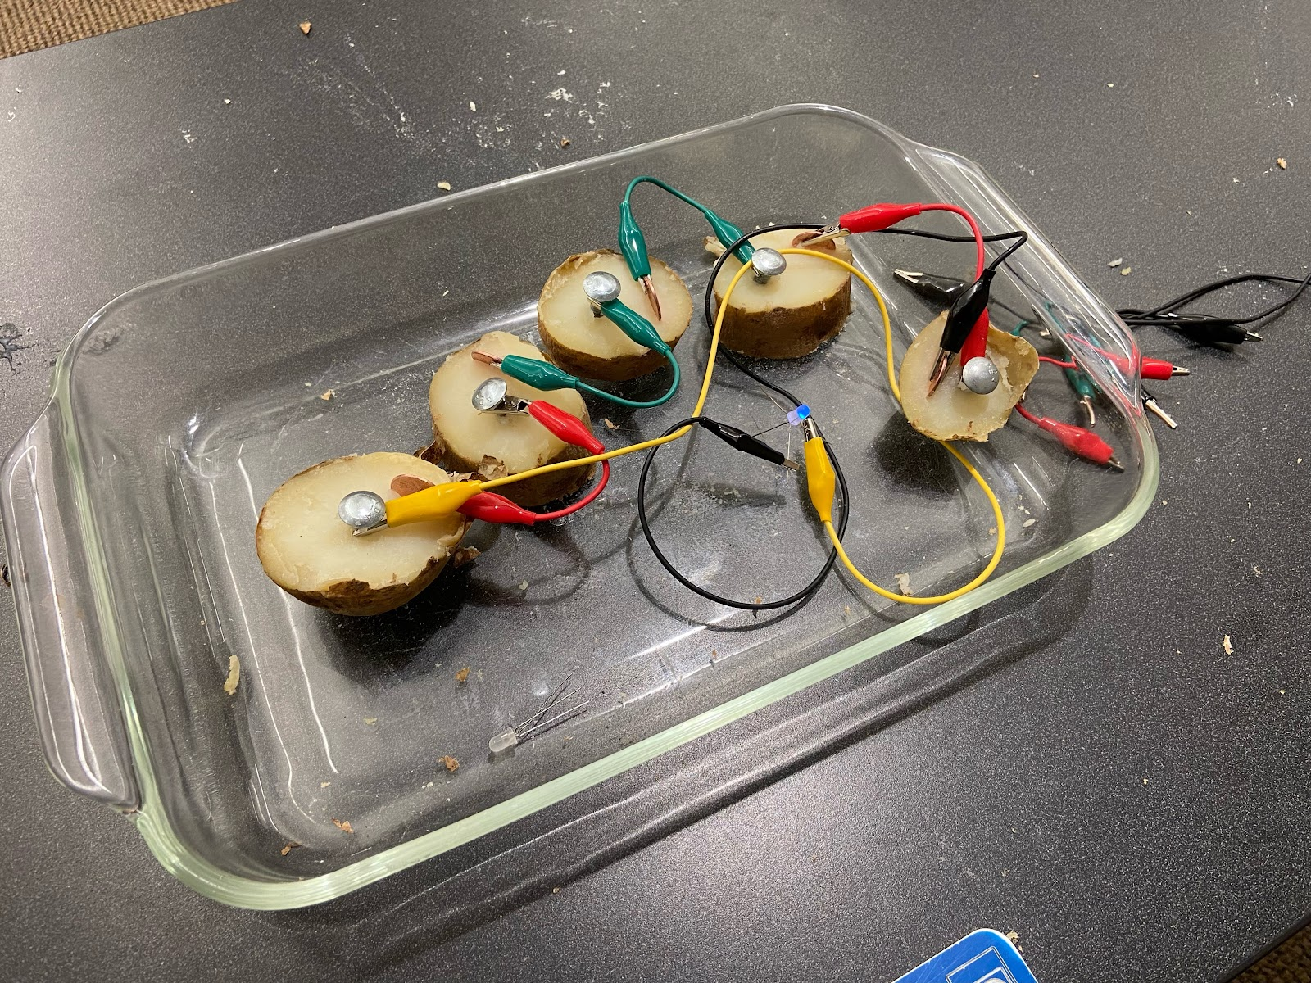

Materials Needed (“N” is amount of partial cells we need)

1. Electrolytic Food Item (2)
2. Copper Cathode (N)
3. Zinc Anode (N)
4. Short Jumper Alligator Clip Wires (N-1)
5. Longer Alligator Clip Wires (2)
6. Glassware to Contain Mess (1)
7. Knife Capable of Cutting Food into Slices (1)
8. Tri-Color LED Diode (2)

**Talking Notes**

Introduce ourselves!! (name, major, year in school, fun fact, etc).

By doing some research we know that copper desires electrons more than zinc, so copper is oxidized and zinc is reduced.

The inside of the potato works as an electrolyte, which means it can dissolve and hold ions of copper and zinc, which is crucial for having a flow of electrons.

One lemon surely can’t power our LED, do any of you freshmen have an idea for how we can get more power?

*Answer is to cut potato to get battery cells in serie*

*Cuts potato*

When this Lemon is cut I will need some volunteers to plug in the oxidized and reduced items to get the chemical reaction to occur.

*ask if there are any questions*

*Have students put electrodes in*

There! Now we’ve generated power.

*While there is still time left answer questions or make small talk*

Let's rotate to the next station to see how else we generate energy.

When a copper and zinc plate are placed inside a lemon, a redox (reduction-oxidation) reaction occurs, generating a small electrical current. The chemical reactions at each electrode can be summarized as follows:

**At the Zinc Electrode (Anode):**

Zinc (Zn) atoms on the surface of the zinc plate lose electrons, becoming positively charged ions:

Zn(s) → Zn²⁺(aq) + 2e⁻

**At the Copper Electrode (Cathode):**

Hydrogen ions (H⁺) from the lemon's acidic juice gain electrons from the copper plate and form hydrogen gas:

2H⁺(aq) + 2e⁻ → H₂(g)

**Overall, the redox reaction can be represented as:**

Zn(s) + 2H⁺(aq) → Zn²⁺(aq) + H₂(g)

The zinc electrode undergoes oxidation (loses electrons) and produces zinc ions, while the copper electrode undergoes reduction (gains electrons) and generates hydrogen gas. This flow of electrons from the zinc electrode to the copper electrode creates an electric current, powering the redox reaction and allowing the lemon to function as a simple electrochemical cell or battery.

**Salt Water Group:**

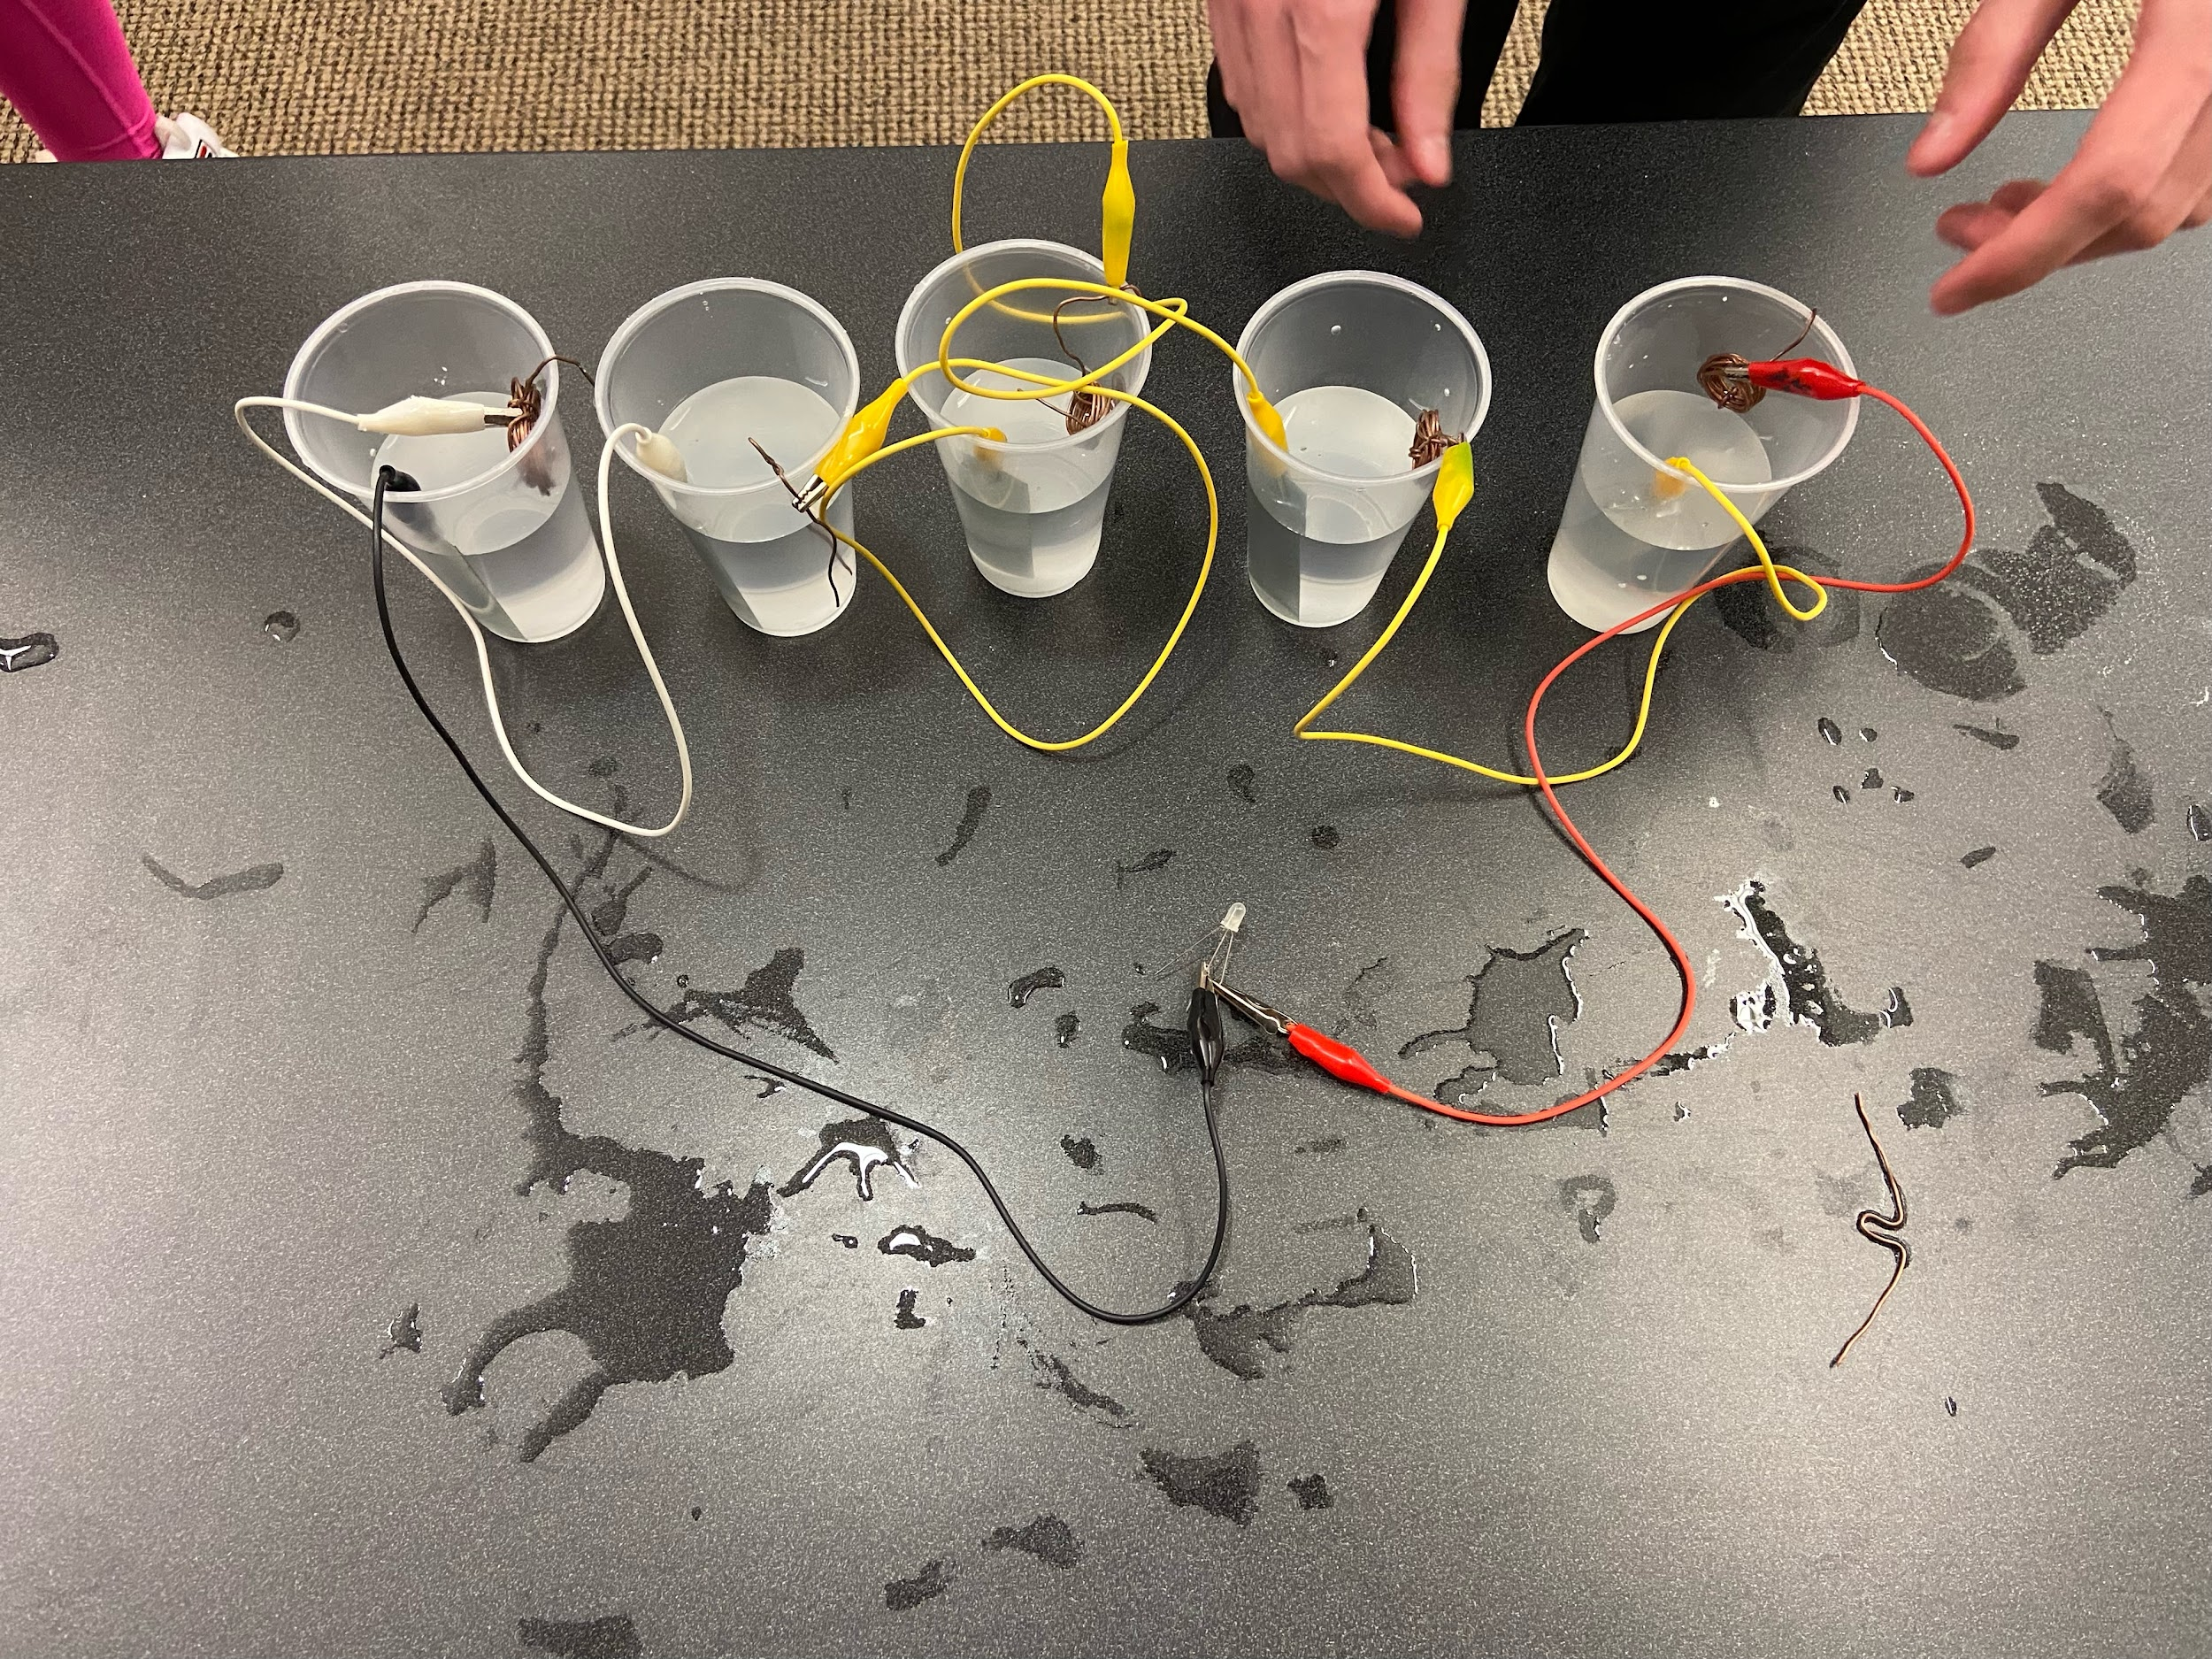

Materials needed (“N” is amount of partial cells we need):

1. Plastic Cups (N)
2. Tablespoons of Salt (N)
3. Deionized Pure Water (Gallon)
4. Copper Cathode Strips (N)
5. Zinc Anode Strips (N)
6. Longer Alligator Clip Wires (N+1)
7. Tri-Color LED Diode (2)

**Talking Notes**

Introduce ourselves!! (name, major, year in school, fun fact, etc).

Explanation: In saltwater batteries, energy is derived from the zinc (nails) and copper (pennies) through the solute and the solvent. The solute is salt because it is what is being dissolved, and the solvent is the water because it is what is doing the dissolving.

(tell students to pour salt)

When we put salt in the water, the water, AKA H₂O, breaks up the salt, AKA NaCl (sodium chloride), into ions; Na⁺ and Cl⁻. Ions are negatively or positively charged atoms, and this charge comes from either an addition or loss of an atom’s electrons. The sodium and chlorine ions are what help the water become conductive to electricity. Does anybody remember James’ explanation of OILRIG? Well, the battery works as electricity is produced by the oxidation-reduction, AKA redox, reaction occurring in the solution. In this scenario, the zinc-like metal from the nail has a positive charge, and since positive forces attract negative forces, it bonds with the chlorine ions from the salt in the solution. Copper ions also have a positive charge, so they will end up bonding with the chloride as well. The way this all works is that there is a current of electrons flowing from zinc to copper. This is because zinc is considered an anode (which gives away electrons) while copper is considered a cathode (which receives electrons), and the energy current always flows from the anode to the cathode. When zinc enters the solution, it breaks up into positively charged zinc ions and 2 electrons. The electrons get sent through the current to the copper ions because copper has a higher electronegativity than zinc, meaning it wants more electrons. The positive zinc ions then bond in the solution with chlorine to create ZnCl₂. Copper ions also bond with Chlorine to create CuCl₂, and when the electrons from the zinc are introduced, copper is able to become reduced into a neutral atom, and chlorine goes back to being a negative ion. All of these components contribute to the electron flow from zinc to copper through saltwater to conduct electricity.

There! Now we’ve generated power.

*While there is still time left answer questions or make small talk*

Let's rotate to the next station to see how else we generate energy.

For experiment:

* Connect the black wire (anode) (zinc (which is giving away electrons - becomes oxidized)) to the shorter (or middle)rod of the LED light (ground). Connect the red wire (cathode) ((copper (which wants to receive the electrons - becomes)) to the longer rod(or left or right rod) of the LED light.

When a copper and zinc plate are placed inside a saltwater (electrolyte) solution, a redox (reduction-oxidation) reaction occurs, similar to the lemon battery. The saltwater serves as an electrolyte, allowing ions to move between the electrodes. The chemical reactions at each electrode can be summarized as follows:

**At the Zinc Electrode (Anode):**

Zinc (Zn) atoms on the surface of the zinc plate lose electrons, becoming zinc ions:

Zn(s) → Zn²⁺(aq) + 2e⁻

**At the Copper Electrode (Cathode):**

Hydrogen ions (H⁺) from the water gain electrons from the copper plate and form hydrogen gas:

2H⁺(aq) + 2e⁻ → H₂(g)

**Overall, the redox reaction can be represented as:**

Zn(s) + 2H⁺(aq) → Zn²⁺(aq) + H₂(g)

Just like in the lemon battery, the zinc electrode undergoes oxidation (loses electrons) and produces zinc ions, while the copper electrode undergoes reduction (gains electrons) and generates hydrogen gas. The movement of ions in the saltwater solution allows for the flow of electrons, creating an electric current and enabling the redox reaction to proceed.